- INTRODUCTION

  - Project Overview

Civil Engineering Insight Studio is an analytical and decision-support platform designed to assist civil engineers, urban planners, and infrastructure authorities in planning, designing, monitoring, and optimizing civil infrastructure projects. The studio integrates engineering data, analytical models, and visualization tools to provide actionable insights across domains such as transportation, structural health, water resources, and urban development.
Rapid urbanization, aging infrastructure, and increasing demand for sustainable development have made data-driven decision-making essential in civil engineering. Civil Engineering Insight Studio addresses these challenges by transforming raw engineering and environmental data into meaningful insights that support safer designs, efficient construction practices, and long-term infrastructure sustainability.
1.2 Objectives
- To develop a centralized analytics platform for managing and visualizing civil engineering project data efficiently.
- To enable data-driven decision-making by providing real-time insights into construction progress, resource usage, and project performance.
- To monitor infrastructure health and safety parameters using structured data analysis and visual dashboards.
- To improve project planning and scheduling accuracy by analyzing historical and real-time construction data.
- To track material usage and cost estimation to reduce wastage and control project budgets.
- To enhance collaboration among stakeholders (engineers, managers, and planners) through shared insights and reports.
- To identify risks and delays early using predictive analytics and trend analysis.
- To support sustainable construction practices by analyzing environmental impact and resource efficiency.
- To provide customizable dashboards and reports tailored to different civil engineering domains such as roads, buildings, and bridges.
- To ensure scalability and reliability of the system for handling large volumes of engineering data.

2. PROJECT INITIALIZATION AND PLANNING PHASE
2.1. Defining Problem Statement
Date | 28 January 2026
Team ID | LTVIP2026TMIDS66183
Project Name | Civil Engineering Insight Studio
Maximum Marks | 3 Marks

Define Problem Statements (Customer Problem Statement Template):

Civil engineering projects generate large volumes of data related to planning, design, construction progress, resource utilization, cost estimation, and infrastructure health. In traditional project management practices, this data is often stored in isolated systems, spreadsheets, or manual records, making it difficult to analyze, visualize, and utilize effectively. As a result, project stakeholders face challenges such as poor visibility into project status, delayed decision-making, cost overruns, inefficient resource allocation, and increased risk of project delays and safety issues.
Existing systems lack an integrated platform that can transform raw civil engineering data into meaningful insights through real-time monitoring and visualization. The absence of centralized analytics tools limits the ability to detect risks early, track performance efficiently, and support data-driven decision-making. Therefore, there is a need for a comprehensive and intelligent solution that consolidates civil engineering project data, provides actionable insights, and enhances planning, monitoring, and management processes.
The Civil Engineering Insight Studio aims to address these challenges by offering a unified analytics platform that enables efficient data management, visualization, and analysis to improve project efficiency, safety, cost control, and overall infrastructure management.
Problem Statement (PS) | I am (Customer) | I’m trying to | But | Because | Which makes me feel
PS-1 | A civil site engineer | monitor construction progress and site performance | project data is scattered across reports, spreadsheets, and manual logs | there is no centralized system to visualize and analyze real-time project data | confused and unable to make quick decisions
PS-2 | A structural or infrastructure engineer | assess infrastructure health and safety conditions | analyzing large volumes of inspection and monitoring data is difficult | data visualization and trend analysis tools are limited | uncertain and concerned about safety risks
PS-3 | A construction company stakeholder | ensure timely project delivery within budget | delays and risks are identified too late | there is no predictive or insight-driven monitoring system | frustrated and financially pressured

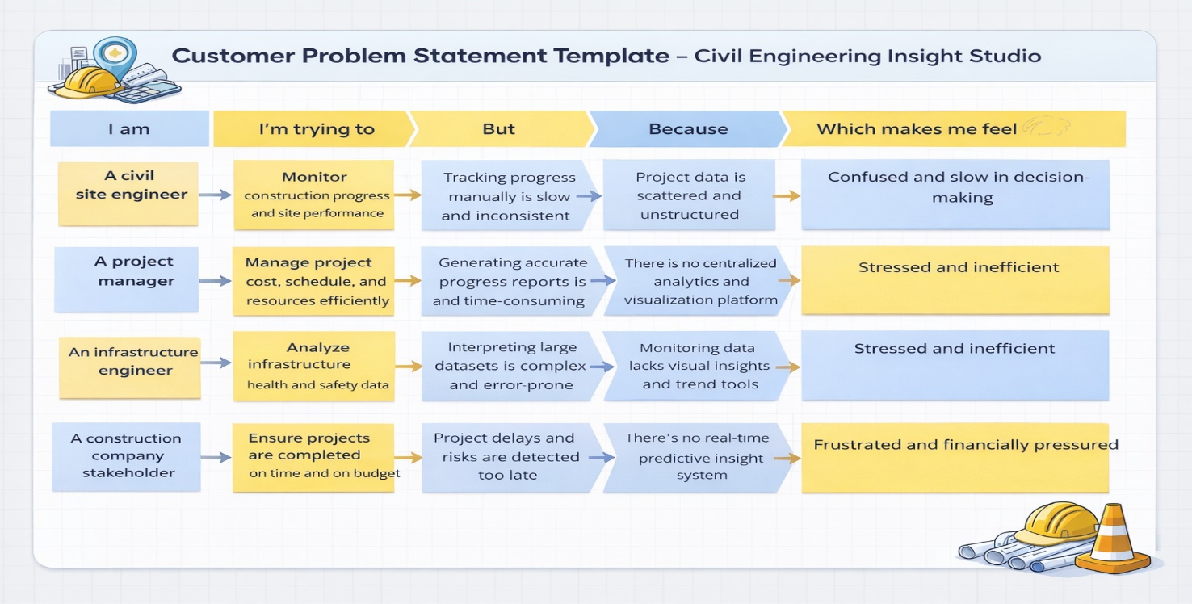
Reference: https://miro.com/templates/customer-problem-statement/

2.2. Project Proposal (Proposed Solution)
Date | 31 January 2026
Team ID | LTVIP2026TMIDS66183
Project Title | Civil Engineering Insight Studio
Maximum Marks | 3 Marks

Project Proposal (Proposed Solution) template
Civil Engineering Insight Studio For Your Next Journey is a centralized data analytics and visualization platform designed to support efficient planning, monitoring, and management of civil engineering projects. The system transforms fragmented project data into meaningful insights that assist engineers, managers, and stakeholders in making informed decisions. The application is built using Streamlit and provides a simple interface for users to make decisions and assist work quickly.
Project Overview
Objective | The objective of our Civil Engineering Insight Studio project is to develop a centralized analytics platform that provides real-time insights for effective planning, monitoring, and management of civil engineering projects.
Scope | This project focuses on the development of a data-driven analytics and visualization platform to support effective planning, monitoring, and management of civil engineering projects. The project primarily emphasizes data analysis, reporting, and decision support rather than physical construction activities.
Problem Statement
Description | Civil Engineering Insight Studio is a data-driven analytics and visualization platform that helps monitor and manage civil engineering projects efficiently. It centralizes project data, provides clear insights on progress, cost, and resources, and supports informed decision-making through interactive dashboards.
Impact | It improves efficiency and decision-making in civil engineering projects by providing centralized data analytics and visualization. It reduces manual effort, enhances project transparency, enables early detection of delays and risks, improves cost and resource management, and supports better planning and infrastructure monitoring, leading to more reliable and timely project execution.
Proposed Solution
Approach | Project requirements are first analyzed to identify key metrics and user needs. Relevant civil engineering data is then collected, cleaned, and stored in a centralized database. Analytical techniques are applied to process the data and extract meaningful insights. These insights are presented through interactive dashboards and reports, enabling stakeholders to monitor progress, manage resources, control costs, and make informed decisions effectively.
Key Features | - Centralized data management for civil engineering projects  - Real-time monitoring of construction progress  - Cost, schedule, and resource utilization analysis  - Interactive dashboards and visual reports  - Early identification of project delays and risks

Resource Requirements
Resource Type | Description | Specification/Allocation
Hardware
Computing Resources | Standard personal computer | Windows 11 Home Single Language
Memory | Minimum 4 GB | 16 GB
Storage | Minimum 20 GB free space | 256 GB SSD
Software
Frameworks | Python, Streamlit frameworks | Streamlit
Libraries | google-generativeai, streamlit | google-generativeai, streamlit
Development Environment | IDE, version control | Visual Studio Code, Git
Data
Data | Resource data (labor, materials, equipment usage)  Schedule data (planned vs actual dates) | User Input

2.3. Initial Project Planning
Date | 02 February 2026
Team ID | LTVIP2026TMIDS66183
Project Name | Civil Engineering Insight Studio
Maximum Marks | 4 Marks

Product Backlog, Sprint Schedule, and Estimation (4 Marks)
Use the below template to create a product backlog and sprint schedule
Sprint | Functional Requirement (Epic) | User Story Number | User Story / Task | Story Points | Priority | Team Members
Sprint-1 | Project Setup & Infrastructure | USN-1 | Configure the project environment by installing required software tools, libraries, and frameworks needed for developing the Civil Engineering Insight Studio. | 1 | Medium | Suhitha, Aswini
Sprint-1 | Data Collection& Preprocessing | USN-2 | As a developer, I want to collect and preprocess civil engineering project data (loads, materials, dimensions) so that it can be used for analysis and insight generation. | 2 | High | Gowtham, Niteesh
Sprint-2 | Analysis Module Integration | USN-3 | As a developer, I want to integrate structural safety, material optimization, and cost analysis modules into the web application to provide engineering insights. | 2 | High | Aswini, Suhitha
Sprint-2 | Error Handling & Input Validation | USN-4 | As a user, I want to receive proper error messages when incorrect or incomplete project data is entered so that I can correct it easily | 2 | High | Suhitha, Aswini, Niteeshwar Reddy, Gowtham
Sprint-3 | Project Setup & Infrastructure | USN-1 | Configure the project environment by installing required software tools, libraries, and frameworks needed for developing the Civil Engineering Insight Studio. | 1 | Medium | Suhitha, Aswini
Sprint-3 | Data Collection& Preprocessing | USN-2 | As a developer, I want to collect and preprocess civil engineering project data (loads, materials, dimensions) so that it can be used for analysis and insight generation. | 2 | High | Gowtham, Niteesh
Sprint-4 | Analysis Module Integration | USN-3 | As a developer, I want to integrate structural safety, material optimization, and cost analysis modules into the web application to provide engineering insights. | 2 | High | Aswini, Suhitha

3. DATA COLLECTION AND PREPROCESSING PHASE
3.1. Data Collection plan and Raw Data Sources Identified
Date | 05 February 2026
Team ID | LTVIP2026TMIDS66183
Project Title | Civil Engineering Insight Studio
Maximum Marks | 2 Marks

Data Collection Plan & Raw Data Sources Identification
This phase data is collected from project planning documents, construction progress reports, cost and budget records, resource utilization logs, and infrastructure inspection reports, along with simulated and open-source datasets, which are cleaned, validated, and stored in a centralized database for analysis and visualization.
Data Collection Plan
Section | Description
Project Overview | The Civil Engineering Insight Studio is a data-driven analytics and visualization platform designed to support efficient planning, monitoring, and management of civil engineering projects. It centralizes project-related data such as construction progress, cost, schedule, and resource usage, and converts it into actionable insights through analytical processing and interactive dashboards. The system helps engineers, project managers, and stakeholders track performance, identify risks early, and make informed decisions, ultimately improving project efficiency, transparency, and reliability.
Data Collection Plan | Civil Engineering Insight Studio project is collected from project planning documents, construction progress reports, cost and budget records, resource utilization logs, and infrastructure inspection reports. Additional data is obtained from simulated academic datasets and open-source civil engineering sources. The collected data is cleaned, validated, and organized in a centralized database to support effective analysis, visualization, and decision-making.
RawDataSources Identified | The raw data for the Civil Engineering Insight Studio project consists of unprocessed project-related information collected from construction and infrastructure activities. This includes project details, daily and weekly construction progress reports, cost and expenditure records, resource utilization logs, schedules, and infrastructure inspection data. The raw data is initially available in formats such as spreadsheets, CSV files, and manual records, which are later cleaned and structured for analysis and visualization..

Raw Data Sources
Source Name | Description | Location / Source | Format | Size | Access Permissions
User Input – Project Details | Project information entered by the user (project name, location, type) | Web Interface / Application Form | Text | Small (per entry) | Public (User Provided)
User Input – Progress Data | Construction progress updates entered by site engineers | Web Interface / Data Entry Module | Numeric / Text | Small to Medium | Authorized Users
User Input – Cost Data | Budget and expenditure details entered by project managers | Web Interface / Data Entry Module | Numeric | Small to Medium | Authorized Users

3.2. Data Quality Report
Date | 07 February 2026
Team ID | LTVIP2026TMIDS66183
Project Title | Civil Engineering Insight Studio
Maximum Marks | 2 Marks

Data Quality Report
Quality is ensured for all content used in the Civil Engineering Insight Studio by maintaining accuracy, consistency, completeness, and reliability of the data. The collected project data is validated to remove errors, duplicates, and missing values before analysis. Standardized formats and units are used across all datasets to ensure consistency. Regular checks are performed to maintain data integrity, and only authorized users are allowed to enter or modify data, ensuring the overall quality and reliability of the project insights.

Data Source | Data Quality Issue | Severity | Resolution Plan
User Input (Project Details) | Missing or incorrect project information | High | Mandatory fields and input validation ensure complete and accurate project details.
User Input (Construction Progress) | Incomplete or inconsistent progress updates | High | Standardized data entry formats and validation checks are applied.
User Input (Cost & Budget Data) | Incorrect or unrealistic cost values | High | Numeric range validation and cross-checking with budget limits are enforced.
User Input (Resource Utilization) | Missing or inconsistent labor or material data | Moderate | Predefined templates and input constraints are used.
Inspection & Maintenance Records | Outdated or inaccurate inspection data | Moderate | Periodic data review and updates are scheduled.

3.3. Data Preprocessing
Date | 09 February 2026
Team ID | LTVIP2026TMIDS66183
Project Title | Civil Engineering Insight Studio
Maximum Marks | 6 Marks

Preprocessing
Data preprocessing is performed to ensure that the collected raw data is accurate, consistent, and suitable for analysis. Initially, the raw data from various sources is cleaned by removing duplicate records, correcting errors, and handling missing values. Data formats, units, and naming conventions are standardized to maintain consistency across datasets. Outliers and invalid entries are identified and treated appropriately to improve data reliability

Section | Description
Data Overview | The data used in this project consists of civil engineering project inputs such as project details, construction progress, cost, schedule, resource usage, and inspection records. The data is collected through user inputs and simulated project datasets.
Data Cleaning | Raw project data is cleaned by removing duplicate records, correcting inconsistencies, and handling missing or invalid values.
Input Validation | Ensures that mandatory project fields are completed, progress values are within valid ranges, cost data is realistic, and resource usage entries are non-negative.
Data Standardization | Standard units, formats, and naming conventions are applied across all datasets to maintain consistency.
Analytical Processing | Validated and standardized data is processed using analytical techniques to derive project performance metrics and trends.
Error Handling | The system handles invalid inputs and processing errors gracefully by displaying appropriate messages and preventing system failure.
Data Preprocessing Templates
Loading Data | Project-related inputs such as project details, construction progress, cost, schedule, and resource usage are collected through the application interface using text and numeric input fields.
Input Validation | Validation logic ensures that all mandatory fields are filled and that numeric values (cost, progress percentage, resource quantities) fall within acceptable ranges before further processing.
Data Structuring | The validated inputs are organized into a structured data format suitable for analysis and storage.
Analytic Handling | The structured data is processed using analytical methods to compute project performance metrics, trends, and indicators
Output Handling | The generated insights, reports, and visual dashboards are displayed through the application interface for user review and decision-making.

4. MODEL DEVELOPMENT PHASE
4.1. Model Selection Report
Date | 12 February 2026
Team ID | LTVIP2026TMIDS66183
Project Title | Civil Engineering Insight Studio
Maximum Marks | 5 Marks

Model Selection Report
In this project, the focus is simple analytical models are chosen due to their transparency, ease of interpretation, and suitability for structured civil engineering project data. These models ensure reliable insights and efficient system performance. The modular design of the platform also allows future integration of advanced machine learning models, such as predictive models for delay and cost estimation.
Model Selection Report:
Model | Description
  Analytical Processing Model (Rule-Based & Statistical Models)
  A lightweight and efficient analytical approach used to compute civil engineering project metrics such as construction progress, cost variance, schedule variance, and resource utilization. This model is well-suited for real-time project monitoring and provides transparent, easy-to-interpret insights.
  Other Models (Considered)
  Advanced machine learning and predictive models were conceptually reviewed, but rule-based and statistical models were selected due to their simplicity, reliability, faster processing time, and suitability for structured civil engineering project data. These models also allow easy future integration of AI-based prediction techniques if required.

Justification for Model Selection
The analytical processing model based on rule-based and statistical techniques is selected for the Civil Engineering Insight Studio project due to its suitability for structured civil engineering project data. These models provide clear, transparent, and easily interpretable results, which are essential for engineers and project managers to understand project performance metrics such as progress, cost variance, and resource utilization. They require minimal computational resources, ensure fast response times, and reduce system complexity. Additionally, this model supports reliable real-time monitoring and allows seamless future integration of advanced machine learning or predictive models if needed.
4.2. Initial Model Training Code, Model Validation and Evaluation Report
Date | 15 February 2026
Team ID | LTVIP2026TMIDS66183
Project Title | Civil Engineering Insight Studio
Maximum Marks | 10 Marks

Initial Model Training Code, Model Validation and Evaluation Report
This project does not involve custom machine learning model training. Instead, it utilizes analytical processing models to analyze structured civil engineering project data. Therefore, this phase focuses on model initialization, rule-based computation, analytical processing, and output evaluation rather than traditional model training and validation.
Model Initialization and Integration (5 marks):
The analytical processing model used in the Civil Engineering Insight Studio project is based on predefined rules and statistical calculations implemented within the application backend. The model is initialized by configuring project-specific parameters such as progress thresholds, cost variance limits, and scheduling constraints.
The system receives structured inputs including project details, construction progress updates, cost data, resource utilization, and schedule information. Based on these inputs, the analytical model computes key performance indicators such as project completion percentage, cost variance, schedule variance, and resource efficiency metrics.

Model Validation and Evaluation Report (5 marks):
Model validation in the Civil Engineering Insight Studio project ensures that the analytical processing model produces accurate, consistent, and reliable project insights. Since the project uses rule-based and statistical analytical models rather than trained machine learning models, validation focuses on correctness of computations and reliability of outputs.
Validation is performed by comparing the model-generated metrics, such as project progress percentage, cost variance, and schedule variance, with manually calculated results using sample project data. Input boundary testing is conducted to verify that the model handles minimum, maximum, and invalid values correctly. Consistency checks ensure that repeated inputs produce identical results, confirming model stability.

5. MODEL OPTIMIZATION AND TUNING PHASE
5.1. Tuning Documentation
Date | 18 February 2026
Team ID | LTVIP2026TMIDS66183
Project Title | Civil Engineering Insight Studio
Maximum Marks | 10 Marks

Model Optimization and Tuning Phase
The Model Optimization and Tuning Phase in the Civil Engineering Insight Studio project focuses on improving the efficiency, accuracy, and reliability of the analytical processing model rather than adjusting machine learning parameters. Since the project uses rule-based and statistical models, optimization is achieved by refining calculation logic, improving data handling, and enhancing system performance.
Threshold values for project metrics such as progress completion, cost variance, and schedule deviation are adjusted to better reflect real-world civil engineering scenarios. Data preprocessing rules are optimized to reduce noise, handle missing values effectively, and ensure consistent inputs. Computational workflows are streamlined to minimize processing time and improve responsiveness of dashboards and reports.
Performance testing is conducted to ensure the system handles multiple project records efficiently without degradation. These optimization and tuning activities enhance the overall accuracy and usability of the Civil Engineering Insight Studio, ensuring reliable insights for effective project management.
Model | Tuned Parameters | Description
Analytical Processing Model (Rule-Based & Statistical) | Threshold Values | Defines acceptable limits for project progress, cost variance, and schedule deviation to identify risks accurately.
 | Data Validation Rules | Ensures input values are within realistic and acceptable ranges for civil engineering projects.
 | Aggregation Logic | Controls how data is summarized across tasks, phases, and projects to provide meaningful insights.
 | Update Frequency | Determines how often analytics and dashboards are refreshed to reflect the latest project data.

Hyperparameter Tuning Documentation (8 Marks):
The Civil Engineering Insight Studio project does not employ machine learning models that require traditional hyperparameter tuning. Instead, the system uses rule-based and statistical analytical models, where tuning focuses on adjusting operational parameters to improve accuracy, reliability, and performance of project insights.
Multiple test scenarios, including normal progress, delayed execution, and budget overrun cases, are used to evaluate and fine-tune these parameters. Through iterative testing and adjustment, the system achieves consistent and reliable analytical outputs, ensuring effective decision support for civil engineering stakeholders.

Optimization Approach

Optimize data preprocessing to remove noise, duplicates, and inconsistencies

Refine rule-based and statistical calculations for accurate project metrics

Tune threshold values for progress, cost variance, and schedule deviation

Improve data aggregation logic for meaningful project-level insights

5.2 Final Model Selection Justification (2 Marks):
Final Model | Reasoning
Analytical Processing Model (Rule-Based & Statistical Models) | The final model configuration provides an optimal balance between accuracy, interpretability, and execution speed for civil engineering project analysis. The tuned thresholds, validation rules, and aggregation logic improve the reliability of project insights without increasing system complexity, making the model well-suited for real-time monitoring and decision support in civil engineering projects.

6. RESULTS
6.1. Output Screenshots
The complete execution of Civil Engineering Insight Studio application is represented step by step in the following screenshots.
Step 1: To run the Streamlit Application we have to use the command streamlit run app.py in the terminal
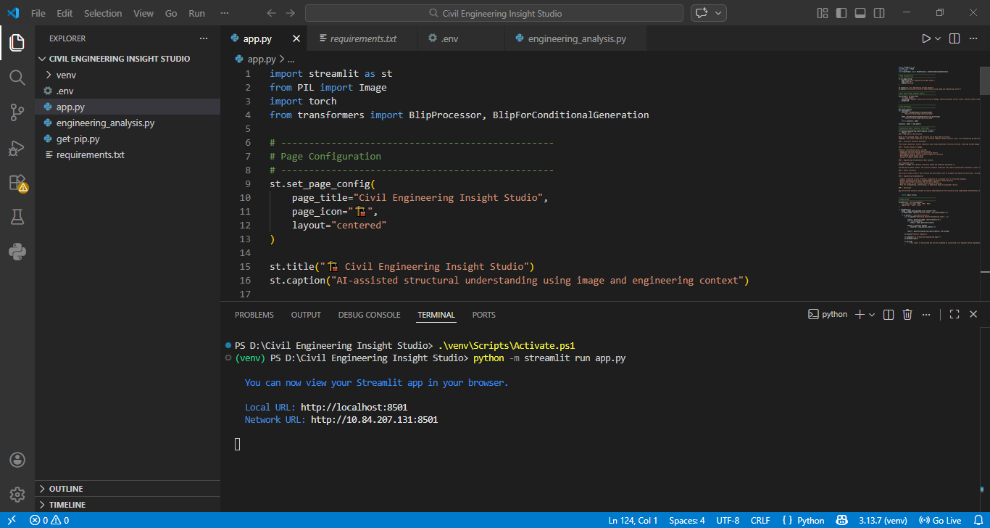
Fig 6.1.1:code running in terminal
Step 2: Opening the Application in Browser
Open your browser and navigate to:
- http://localhost:8501
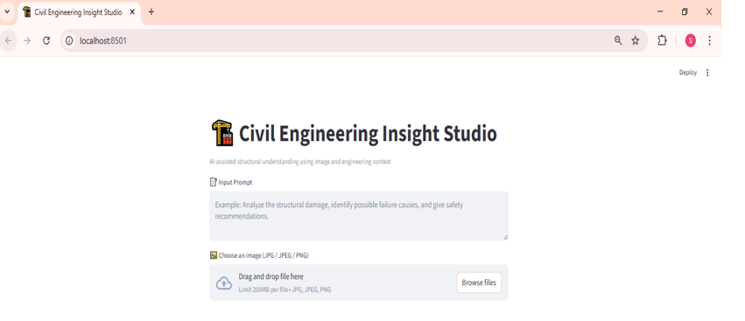
Fig 6.1.2:Home page Interface
Step 3: The user has to upload the images of building to predict the reports
- Drag the image click enter.
- The backend processes the request using the trained model and encoder.

Fig 7.13: Input the image

Step-4: Viewing the Prediction Output
- The predicted insights /reports shown below:
- Screenshot Example:
- 📸 Prediction result shown below the form: " Civil Engineering Insight Studio: Reports "
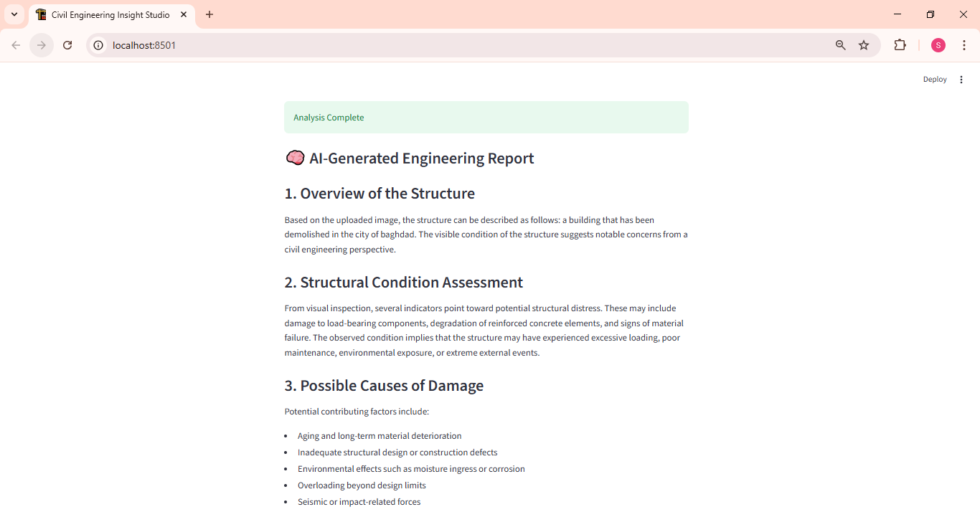

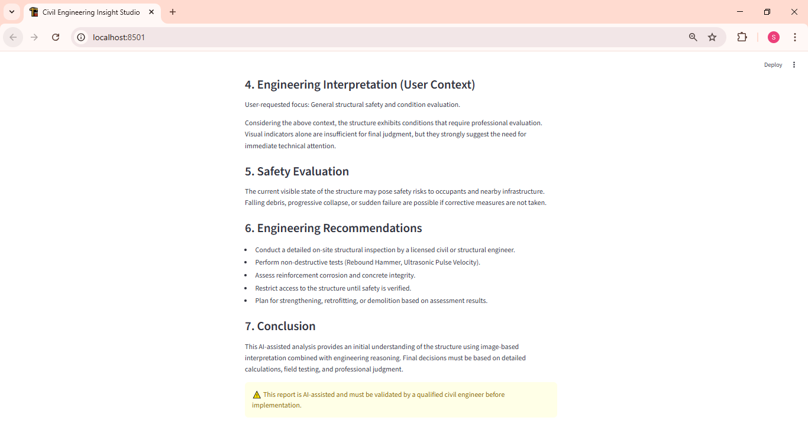
Fig 6.1.4: Predicted Outputs

7. ADVANTAGES AND DISADVANTAGES
7.1 Advantages:
1. Improved Decision-Making
Provides data-driven insights that help civil engineers and planners make informed decisions during design and construction phases.
2. Enhanced Structural Safety
Analyzes loads, stress, and safety factors, reducing the risk of structural failures and improving reliability.
3. Cost Optimization
Supports material comparison and cost analysis, helping minimize construction expenses and material wastage.
4. Time Efficiency
Reduces manual calculations and report preparation by automating analysis and insight generation.
5. Sustainability Support
Evaluates environmental impact and promotes eco-friendly construction practices.
6. Better Project Monitoring
Helps track project performance, progress, and key metrics throughout the project lifecycle.
7. Scalability
Can be extended to different civil engineering domains such as buildings, roads, bridges, and urban infrastructure.
8. Academic & Industry Use
Useful for students, researchers, and professionals for learning, analysis, and planning purposes.
7.2 Disadvantages
1. Dependency on Input Data Quality
Incorrect or incomplete project data can lead to inaccurate analysis and insights.
2. Initial Setup Effort
Requires time and effort to configure analytical models and project parameters.
3. Limited Real-Time Integration
Early versions may not support live site data or sensor integration.
4. Learning Curve
Users may need basic training to effectively use analytical features and dashboards.
5. Computational Requirements
Complex analysis may require higher computational resources for large projects.
6. Limited Automation in Early Stages
Some engineering decisions may still require manual validation and expert judgment

8. CONCLUSION
The Civil Engineering Insight Studio project can be enhanced by integrating advanced AI and machine learning models for predictive analysis and failure detection. Real-time data from construction sites and sensors can be incorporated for live monitoring. Integration with BIM and CAD tools will improve design accuracy and collaboration. Cloud-based deployment can enable multi-user access and large-scale project handling. The platform can also be expanded to support smart city and infrastructure planning applications.

9. FUTURE SCOPE
- Integration of AI and machine learning models for predictive analysis of project delays, cost overruns, and risk assessment.
- Real-time data collection using IoT sensors for infrastructure health and site monitoring.
- Integration with Building Information Modeling (BIM) systems for advanced visualization and planning
- Cloud-based deployment for scalability and remote access
- Development of a mobile application for on-site data entry and monitoring
- Advanced reporting with automated alerts and recommendations
- Support for smart city and large-scale infrastructure projects

10. APPENDIX
Source Code:
All codes are submitted in Git-Hub Repository.
Git-Hub Repository Link:
Civil-Engineering-Insight-Studio-project
Project Demo Link:
https://drive.google.com/file/d/1qpsdvMhTD0QAe--R4HJQe3mXXMu_zJVL/view?usp=drivesdk

